PK/PD ADAM dataset
Terminology
ADAM : Analysis Data Model
ADME : Absorption, Distribution, Metabolism, Excretion
Pop PK : Analysis of data from a whole population using a unified model
AUC(Area Under the Curve)_last : the area under the plasma concentration-time curve from time zero to the last measurable concentration.
SDTM – PC, PP ( Pharmacokinetics Concentration, Pharmacokinetics Parameters.)
Ex )
SDTM PC = raw concentration-time data
STUDYID USUBJID PCSEQ PCTESTCD PCTEST PCORRES PCORRESU PCTPT PCTPTNUM PCDTC
---------------------------------------------------------------------------------------------------------
ABC123 ABC-001 1 DRUGC Drug Conc 0.000 ng/mL PREDOSE 0 2023-01-05T08:00
ABC123 ABC-001 2 DRUGC Drug Conc 150.23 ng/mL 1HR 1 2023-01-05T09:00
ABC123 ABC-001 3 DRUGC Drug Conc 98.45 ng/mL 2HR 2 2023-01-05T10:00
ABC123 ABC-001 4 DRUGC Drug Conc 45.12 ng/mL 4HR 4 2023-01-05T12:00
ABC123 ABC-001 5 DRUGC Drug Conc 12.50 ng/mL 8HR 8 2023-01-05T16:00
ABC123 ABC-001 6 DRUGC Drug Conc 3.20 ng/mL 12HR 12 2023-01-05T20:00
SDTM PP = summary PK parameters derived from PC
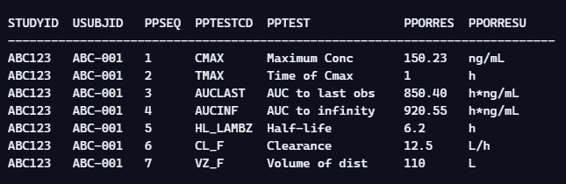

SDTM EX = Exposure / Dosing Records
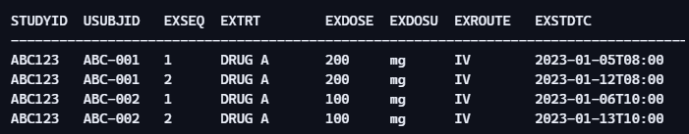
SDTM DM = Demographic
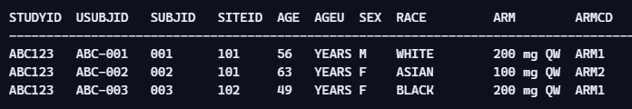
- ARM / ARMCD : Treatment Group

